The history of education in the Snugboro/Carrowbrinoge area goes back to the mid-nineteenth century. Children from surrounding areas who were interested in learning were taught by a travelling teacher at the rear of where McGough's house now stands. In winter they used McGough's barn. The teacher was paid in money and often by vegetables and poultry. Each time the travelling teacher came round families would take turns in keeping him in their homes.
Most parents fought hard for the provision of a school in the area but schools were very uncommon in Mayo. the clergy did not want to get involved with the English in establishing schools. Following the death of Bishop MacHale there was a complete change in the education system in the Tuam Diocese. Schools sprung up everywhere in the 1880's - Snugboro was no different.
In 1859 a site was chosen in Carrowbrinoge on the land owned by Lord Kilmaine, now owned by the McGough family. The site was chosen because it was central to the surrounding townlands of Tullycommons, Snugborough, Drumnacarta, Coarsepark and Derrymaunus. On the 27/8'89 a grant of £254 was approved for the building of a school in the Snugboro area. In the parish of Aglish an extra £53 was made available for the building of a house for the teacher. This was situated a few hundred yards from the school, now occupied by Puline Bourke.
The work on Snugboro school commenced in September 1889 and it was built from stones and lime gathered in the area by men like Thomas McTigue, John McGough, Stephen McHale and John McDermott and carried by donkey and cart to the site. As the Department would not recommend an additional grant for the use of cement, the front walls were left bare until 1906 when they were plastered.
On the 23rd October, 1890, the school was opened by Rev. John McGough and named St. Peter's N.S., Snugborough, even though it was in the Carrowbrinoge townland. The first teacher appointed was Mr. David Joyce, assisted by his wife and daughter who was employed as a monitor. the attendance at the school in the first few years was around 120. Emigration was rampant in those years following the economic situation after the Famine and parents wanted their children to have some form of learning before emigrating.
The 3 R's formed a large part of the curriculum - reading writing and arithmetic. Pupils wrote on slates with chalk and sat on large wooden benches. In the year 1915 Mr. and Mrs. Joyce left the school and returned to their native Newport where they purchased a pub. They later emigrated to England. Mr. Joyce, principal, was replaced by Mr. O'Quigley, a native of Co Sligo, who had been teaching in the Midlands where he met and married his wife who was a Carlow woman by birth. Mr. and Mrs. O'Quigley with their large family, moved into the teacher's residence. Their family included in future years a priest, Fr. Michael, a nun, Mairead, a barrister and a number of teachers, all of whom taught in St. Peter's N.S., Snugboro.
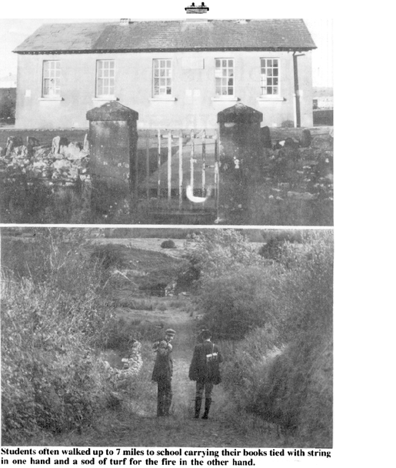The numbers on the roll increased so that by 1918 the average attendance warranted the appointment of a third teacher. Mr. Henry Hoban was appointed. Mr. O'Quigley was very involved in politics and stood as a labour candidate in many elections. the two male teachers taught in the big classroom while the mistress taught the infants in the other room.
The heating arrangement was that each pupil brought two sods of turf to the school each morning. As Pat Quigley recalls, anyone with a stack of turf near the school found it diminished as the term progressed! The sods were inspected for quality and dampness. As there was no free secondary education most pupils waited on until they were fourteen or fifteen. The older students helped on the farm during the summer months.
In Easter, 1935, the late Mr. Henry Hoban left Snugboro N.S. to take up an appointment in Derrywash. His position was filled by Martin Heverin, Liscromwell. Easter 1937, saw another change in Snugboro N.S. when the area was shocked by the death of Mrs. O'Quigley. As the average attendance had dropped below 95, no one replaced Mrs. O'Quigley.
There was now the unique situation where there were two male teachers teaching in a mixed school. About that time Mr. O'Quigley built a house in Blackfort and he then left the teacher's residence for his new home. In July, 1937, Mr. Heverin moved to Burren N.S. and was replaced by Mrs. Mary Hanley who, along with her daughter, Joan, moved to the teacher's residence.
Major repairs and renovations were carried out in 1939 and in 1943 Mr. O'Quigley retired having spent twenty-eight years in Snugboro N.S. He later moved to Dublin where he died. In 1943 the late Eddie Cocoran took up the position of principal. He had formerly taught in Breaffy. In 1948 his untimely death took place and he was succeeded by his brother, Richard Corcoran.
The depressed economic conditions of the fifties took its toll on the enrolment of the school. The average attendance dropped below the fifty mark which was the figure set by the Department of Education for the retention of a trained assistant teacher at a school. In 1957 Mrs. Mary Hanley was appointed to the teaching staff of the boys' N.S. Castlebar where she came to be affectionately known as "Mammy Hanley". Miss Fionula McTigue, daughter of Mr. and Mrs. Andy McTigue, N.T., Blackfort, took up the position vacated by Mrs. Hanley.
By the mid sixties Mr. Richard Corcoran had fallen into ill-health and he retired. He was replaced by the present principal, Mr. Michael Cunningham. Shortly after his appointment major renovations took place In the summer of 1968 electric light and central heating were installed. Also the existing dry toilets were converted to flush toilets.
The days of the sod of turf were over for ever. As the economic climate of the late sixties and seventies began to improve, many young couples married and settled in the area. Enrolment at the school began to increase and by 1978 the number had risen to over eighty and so a third teacher was appointed. She was Mary Armstrong from Tubbercurry.
The year 1979 was a very eventful one in the school's history. The first case was the bad news that Mrs. Flanagan's husband, Michael, had been transferred to Dublin. A special social was held in St. Gerald's Club, Castlebar, at which she was presented with a canteen of cutlery.Next came the news that Fe. Arthur Devine, who had been manager of the school for ten years, had been transferred to Taugheen. Also the news came that Mrs. Armstrong was leaving for Sligo. Fr. Michael Goaley replaced Fr. Devine, Miss Marie Gibbons replaced Mrs. Armstrong and Mrs. Angela Gavin was appointed to the other vacancy in the school. Also in August 1979, Mr. Richard Corcoran died.
By this time the Department had decided that the old school had become seriously overcrowded and outmoded. A site was acquired in 1980 and development on the site was carried out. the wheels of the Government Department move slowly and, meanwhile, the school numbers continued to grow. By Christmas, 1985, the number on the roll was 110. In June, 1984, a fourth teacher, Miss Josephine Curran, was appointed. In 1984 Fr. Gerry Needham took over Fr. Goaley's position.
September, 1985, saw the new school commence in McGough's field at the crossroads. The long years of waiting were over and at last the clouds of depression were scattered. a new era dawned when the pupils and teachers moved into the new school on 2nd September 1985.
May it last well into the 20th century to serve the community.
A brief history of the new school at
Snugboro, Castlebar
In 1978 the existing school at Snugboro was condemned and a new school was recommended. After much viewing of sites by engineers one was chosen at the crossroads as being the most suitable. The site was approved by the Board of Works. It was purchased from its then owner, Mr Jack McGough, for an agreed sum. Some necessary works were carried out by Messrs. Padriag McTigue and Tony Dempsey.
About this time - 1980/'81 - some fund-raising activities were organised by the Management Board under the chairmanship of Rev. Fr. Michael Goaley, C.C. Firstly, a raffle was held which raised £1,000. In February, '81, a sale of work was held in the Welcome Inn Hotel, Castlebar. Due to the tremendous work of the committee and the generosity of the people almost £1,200 was raised. At Christmas, '81, a cake sale was organised which yielded £400.
Meanwhile the paperwork concerning the site for the school was progressing slowly. By the summer of '83 the legal work was finally completed and the site was cleared for application for planning permission. This application was lodged in September, 1983, and planning permission was granted by Christmas of that year.
Early in 1984 Fr. Michael Goaley became seriously ill and was incapacitated for a number of months. In July, 1984 it was announced that he was to be transferred to Irishtown and he was replaced by Rev. Fr. Gerard Needham.
In November, 1984, a deputation from the area consisting of Fr. Needham, Mr. Michael Cunningham and Mr. Padraig McTigue went to Dublin to meet the Junior Minister at the Office of Public Works, Mr. Joe Birmingham, T.D. They were accompanied at the meeting by Mr. Enda Kenny, T.D., Mr. Padraig Flynn, T.D., and Mr. Denis Gallagher, T.D. It was impresses on the Minister the urgency of providing a new school for this rapidly expanding area beside the county town. After some discussion the following pledges were given:
(a) That the school be ready to start in September, 1985
(b) That the new school should be ready for occupation in September 1986. Happily, the schedule was adhered to as promised. The contract was awarded to T.H. Contractors, Castlebar. They moved onto the site in September, 1985 and despite the bad weather this firm did an excellent job and had the new school ready within the year. Full marks are due to Tom Henry and his staff on a job well done.
In September, 1985 a finance committee was formed in the area to raise funds for the new school. They undertook three projects:
(a) At Christmas a school concert was held which raised £400.
(b) In February, 1986, an American tea party was held in the Welcome Inn Hotel which raised £1,100.
(c) In March, 1986, a Monster raffle raised £1,000.
All three projects were immensely successful due in no small way to the work and dedication of the committee. The work of the finance committee has commenced again this year.
So now after almost ten years of hard work and much waiting, the new school has become a reality. It stands as a fitting tribute to all that effort. Please God, it will serve many future generations of young people from the area. Much thanks is due to all who worked so hard and to all who gave so generously for the sake of the new school.
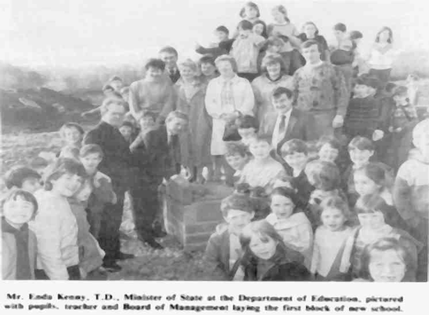
Mr. Enda Kenny. T.D. Minister of State at the Department of Education, pictured with pupils, teachers and Board of Management laying the first block of the new school
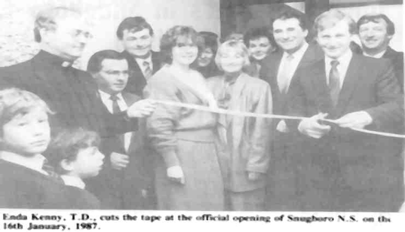
Enda Kenny, T.D. , cuts the tape at the official opening of Snugboro N.S.
on the 16th January, 1987

